HOW A WEBSITE SHOULD LOOK LIKE

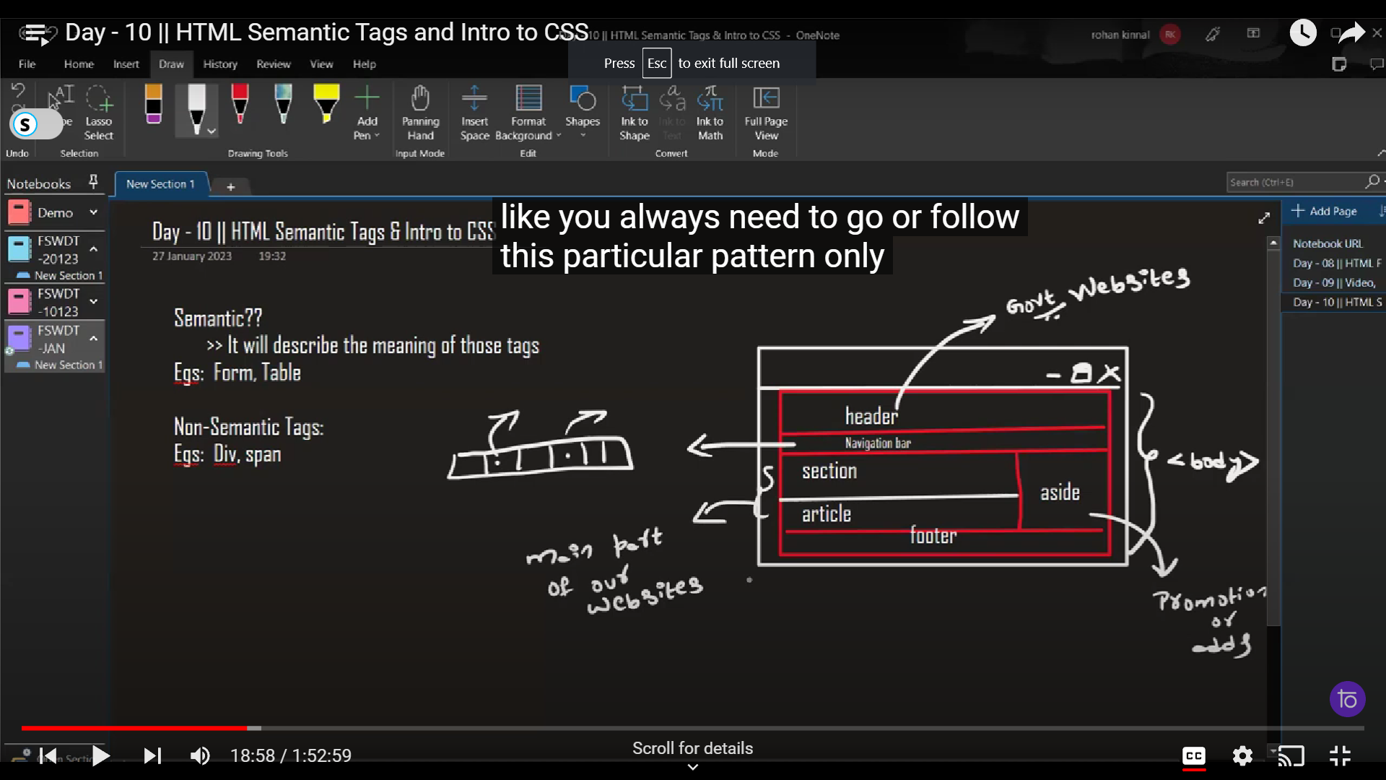

HOW TO WRITE GMAIL ID IN INPUT

